Exercise 5.2

Patrick Weatherford

Bellevue University

DSC 500 T301 2215-1 Spring 2021

Professor Catherine Williams

Exercise 5.2

For this exercise, our goal was to use fictional data and find correlations between the data using the ‘Data Analysis’ add-in in Excel.

## Hemoglobin A1C and Weight

In Figure 1 below, this fictional data shows that there is strong positive correlation between a person’s Hemoglobin A1C and Weight. This indicates that the higher a person’s weight, the higher their Hemoglobin A1C will be.

Figure 1

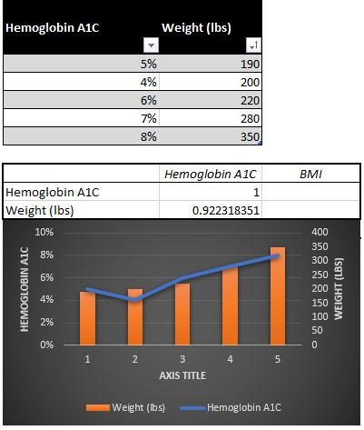

**Outside Temperature and PHQ-9 Scores**

In Figure 2 below, this fictional data shows that there is a strong negative correlation between the outside temperature and a person’s depression scale PHQ-9. This indicates that as the temperature outside gets lower, a person will score higher on a PHQ-9 questionnaire indicating that depression is inversely proportional to outside temperature.

Figure 2

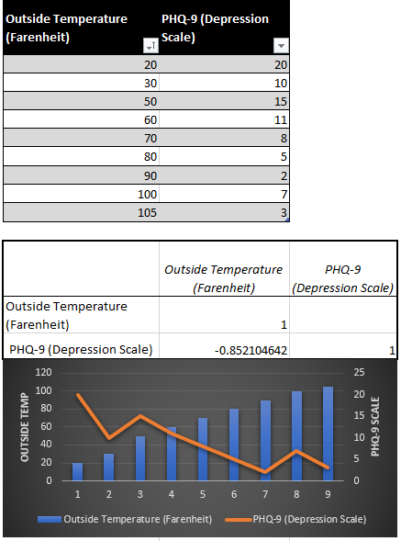

**Autism Spectrum Disorder (ASD) and Father Age at Birth and Child Gender**

In Figure 3 below, this fictional data shows that there is a strong positive correlation between a Father’s age when their child is born and prevalence of Autism Spectrum Disorder (ASD). When further grouping by child gender, the correlation is stronger if the child is a Male.

Figure 3

